**ROS 2 Python package creation**

**ROS2 Tutorials youtube page:**

**https://www.youtube.com/@RoboticsBackEnd**

ROS 2 python package creation is different from traditional ROS1 package creation. Here are the steps needed to follow in order to create a ROS 2 package.

**Step 1: Create python package**

Create dummy ROS 2 python package on terminal

$ ros2 pkg create <package_name> --build-type ament_python --dependencies rclpy

$ ros2 pkg create ros2py_tutorials --build-type ament_python --dependencies rclpy

This will create a package which comes with setup.py & package.xml files. Here **setup.py** is the replacement file of CMakelist for python projects.

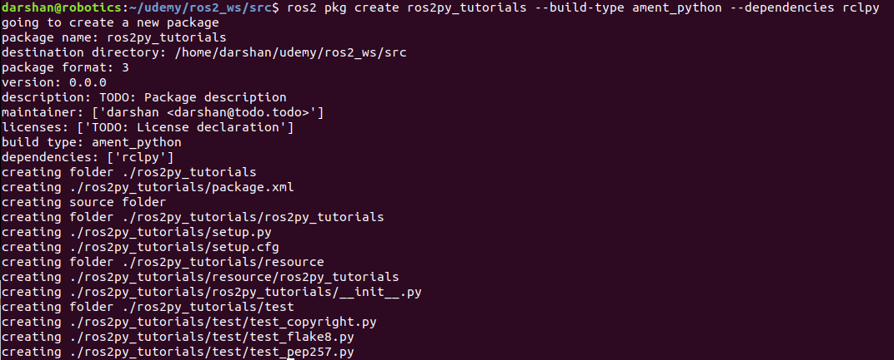

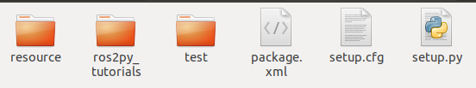

Keep all nodes inside the ros2py_tutorials folder.

Package.xml file

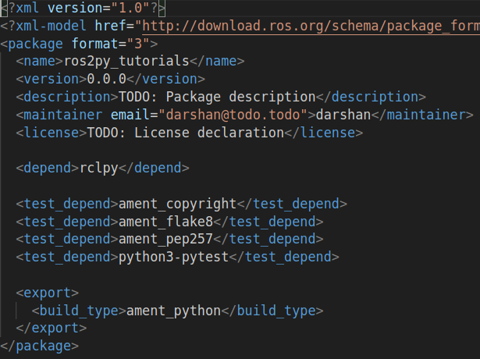

**Note:** Since compiling python scripts, build_type should be **“ament_python”.**

<build_type>ament_python</build_type>

<depend>rclpy</depend>

**Step2 : Build the package:**

$ cd ~ros2_ws

$ colcon build

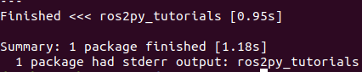

Here inside install folder you can see

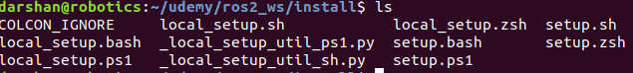

local_setup.bash → This bash file helps to source only this workspace to the terminal.

setup.bash →This bash file helps to source this workspace + global opt ros2 files to the terminal.

**Building particular package:**

colcon build --packages-select ros2py_tutorials --symlink-install

**Note:** Now this python package is ready to host any ros2 python nodes.

**Step 3: Create a minimal python node script**

Get inside the package and name of folder which having the same name as package[where python init.py file located]

$ cd ~ros2_ws

$ cd src/ros2py_tutorials/ros2py_tutorials

$ code first_node.py

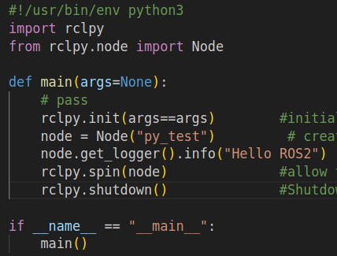

**Step 4** : Edit setup.py file for ros2 node executables

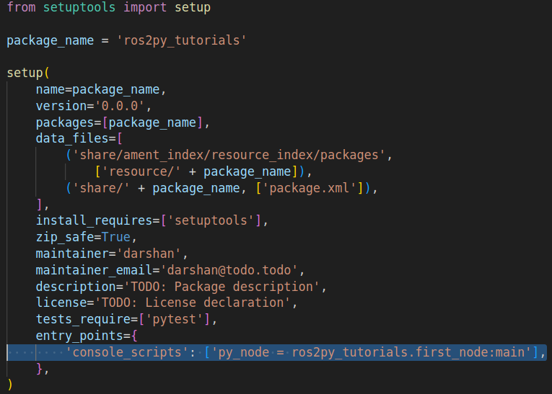

Note: Edit entry_points variable,

entry_points = {‘console_scripts’ : ['**testpy_node = ros2py_tutorials.first_node:main'**] }

Where ,

testpy_node → is the name of executable (optional, you can give preferable one)

ros2py_tutorials → name of package

.first_node → name of file

:main → name of function need to execute inside script

**Compile the package inorder to reflect node executable**

$ colcon build

( or )

$ colcon build --packages-select ros2py_tutorials

**Note:** After successful compilation you have to find the python executable inside the workspace **install** folder

$ ros2_ws$ cd install/ros2py_tutorials/lib/ros2py_tutorials

$ ls



If this executable is not found inside the install folder means “**the package has not successfully compiled python node**”.

In that cases compile the specific package alone which having python node file by using following command

$ colcon build --packages-select <package_name>

**Step 5:** Source workspace on terminal and Run executable ros2 node

$ source install/local_setup.bash

$ ros2 run ros2py_tutorials testpy_node

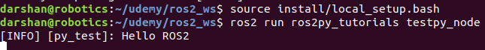

**ROS2 CPP node creation:**

Open src folder inside package and create a ros2cpp file

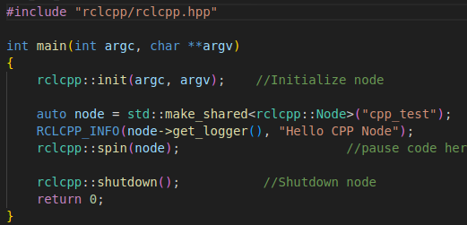

Edit CMakeList file

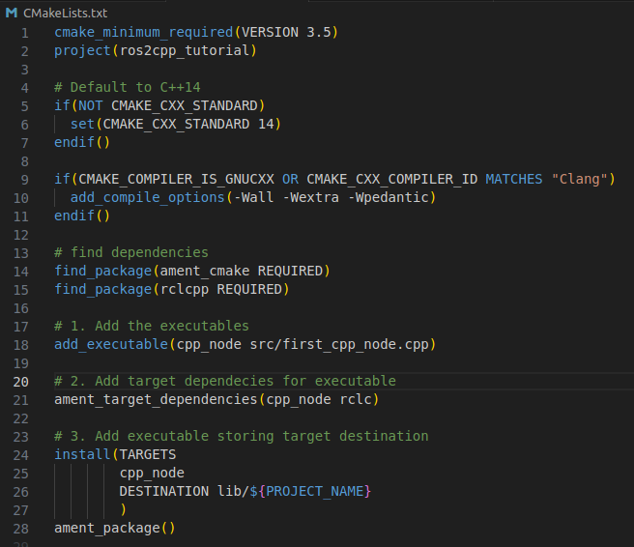

Note: 3 things need to edit inside CMakeList file

1. Add executable for ros2cpp node
2. add_executable(cpp_node src/first_cpp_node.cpp)

Where,

cpp_node → name of executable (its optional user )

src/first_cpp_node.cpp → location of ros2cpp script

2. Add dependencies libraries required to compile node

ament_target_dependencies(cpp_node rclcpp)

cpp_node → name of executable

rclcpp → libraries required to compile

1. Provide the destination to locate executable object file

install(TARGETS

cpp_node

DESTINATION lib/${PROJECT_NAME}

)

The executable file will be stored inside install/package_name/lib/package_name

**Compile ros2cpp node**

$ colcon build --packages-select ros2cpp_tutorial

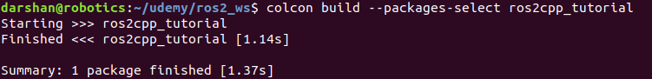

After successful compilation search for executable file



**Run ros2cpp node**

$ source install/local_setup.bash

$ ros2 run ros2cpp_tutorial cpp_node



**ERROR:** Include rclcpp header file with vscode configuration



1. Open the package folder with vscode
2. Get inside the script file, press ctrl+shift+p
3. In search bar type C/C++ → choose “C/C++ : Edit configuration(JSON)
4. This will pop up c_cpp_properties.json file
5. Inside “includePath” add opt folder ros-dashing include folder

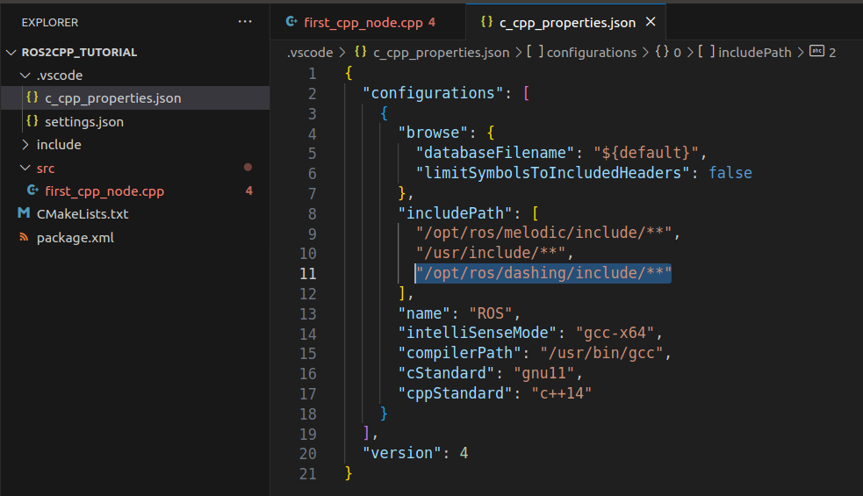

Launch file:

The launch file allows launching multiple nodes in a single file with associated params.

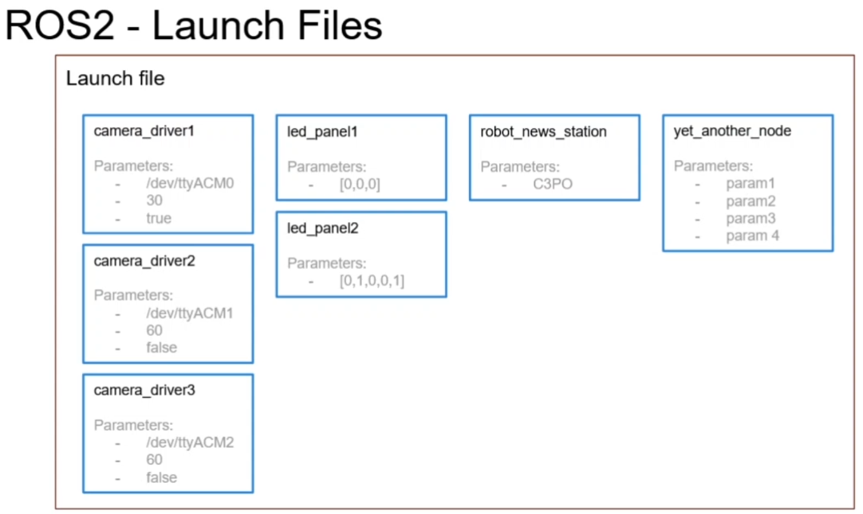

Writing launch files, it is always better to create a separate new package for keeping all the launch files so that it avoids the conflict of dependencies with base packages.

Create a launch file package

$ ros2 pkg create ros2_bringup

Note: No dependencies required for creating launch package, it automatically use ament_cmake as built type.

Create launch folder inside the package & create launch file

$ cd ros2_bringup

$ mkdir launch

$ cd launch

$ code running_nodes.launch.py

Give permission

$ chmod +x running_nodes.launch.py

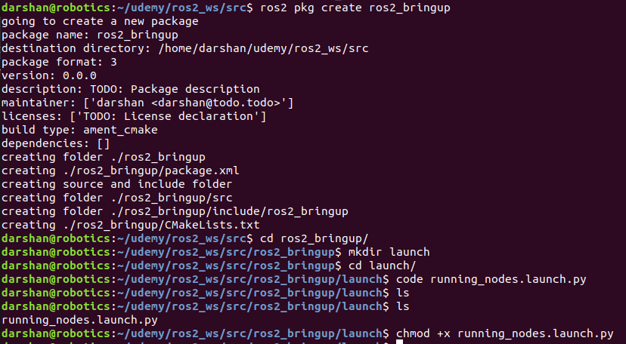

Note: Need to build this launch package with **--symlink-install.** It avoids building the package whenever new changes are added.

Minimal content inside the launch file.

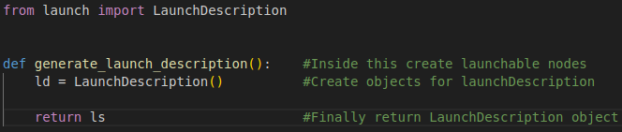

Launch file with node executables

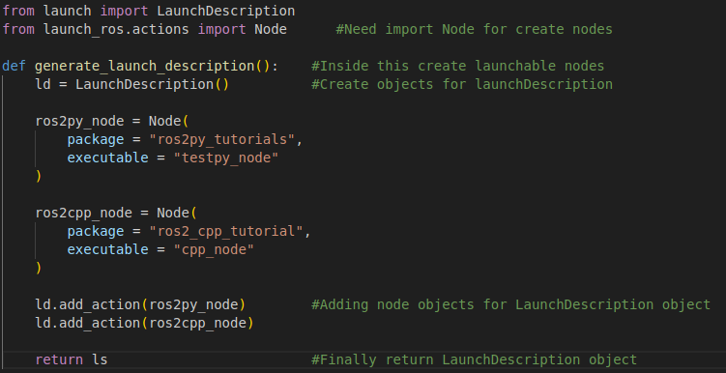

**Note**: ***If you’re using the ros2 dashing distribution, you have to replace the “**executable**” variable with “**node_executable**” inside the node executable object.

node_executable = "cpp_node"

**Edit CMakeList and package.xml files**

CMakeList : Adding the launch folder.

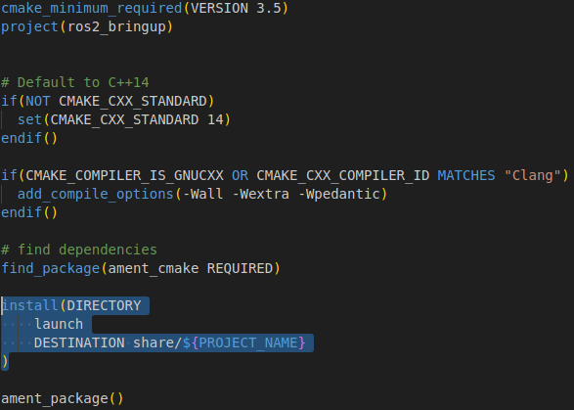

Package.xml : Adding executable nodes carrying package with <exec_depend>.

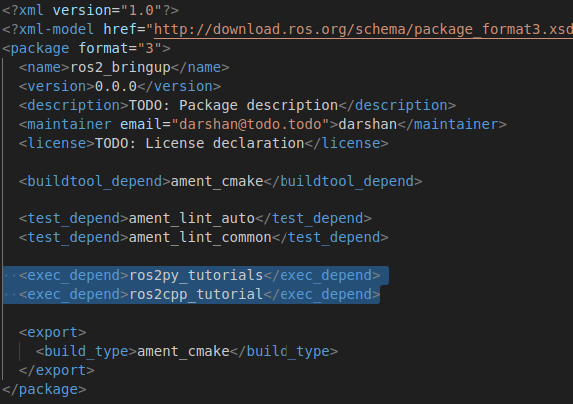

Finally build the package using colcon build with --symlink-install .

$ cd ros2_ws

$ colcon build --packages-select ros2_bringup --symlink-install

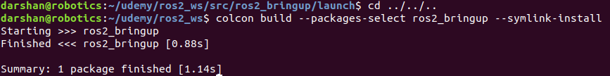

Running launch file

$ source install/local_setup.bash

$ ros2 launch ros2_bringup running_nodes.launch.py



Inspecting nodes using ros2 command line tool

$ ros2 node list

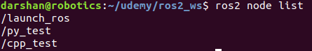

Advanced launch files.

1. Remapping node name

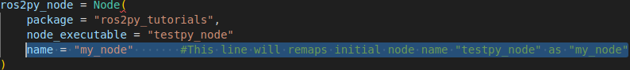

1. Remapping topic name or services name [**Note**: Use tuple/curve brackets]

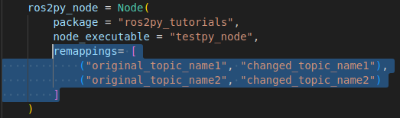

1. Remapping parameters [**Note**: Use dictionary brackets]

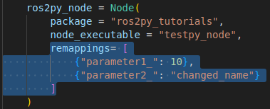

**Step 2:**

Create a ROS 2 node script inside the package inside ros2py_tutorials[package_name] folder.

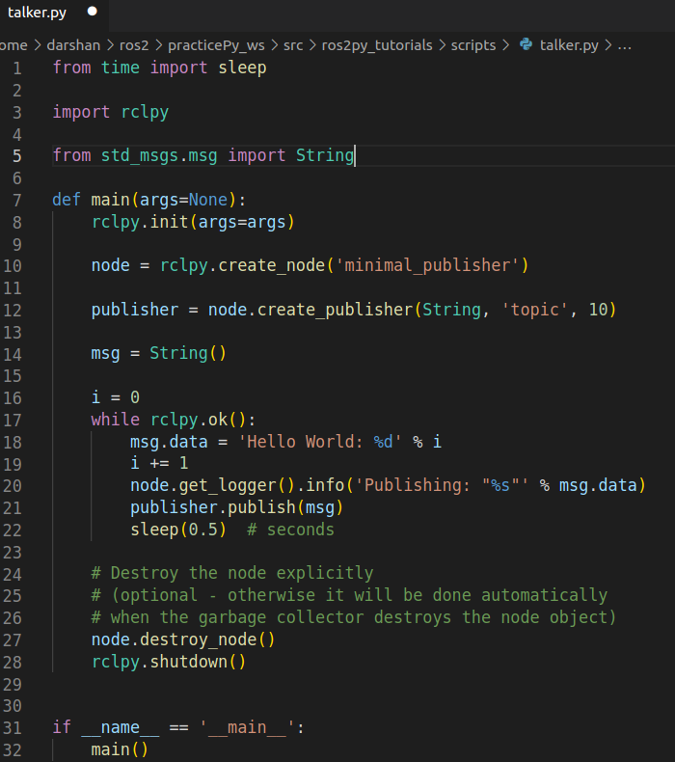

**Step 3:** Edit setup.py for compilation

entry_points = {‘console_scripts’ : ['talker_py_node = ros2py_tutorials.talker:main'] }

Where ,

talker_py_node → is the name of executable

ros2py_tutorials.talker:main → execute the main function of talker

Ex:

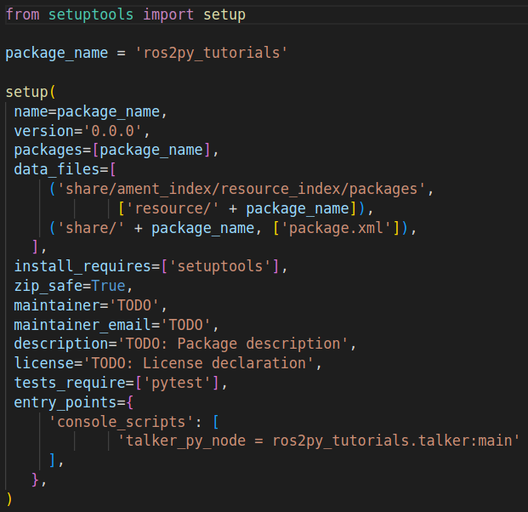

**Step 4:** Build the package

colcon build --symlink-install

After successful compilation you will see build install log folders along with src

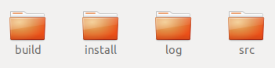

**Step 5:** Source and Run node

source install/local_setup.bash

ros2 run ros2py_tutorials talker_py_node

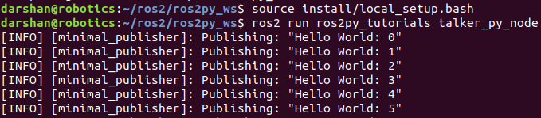

Write a subscriber node and follow the similar steps to compile and execute it.

Like,

Place the subscriber node name called listener_node inside the package inside ros2py_tutorials folder.

Add 'listener_py_node = ros2py_tutorials.listener:main' inside setup.py

Compile using colcon build.

Run node: ros2 run ros2py_tutorials listener_py_node

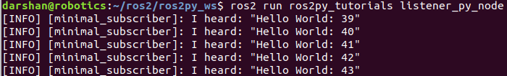

Launch file creation:

**ROS 2 C++ package creation**

Command for creating cpp package with build tool and dependencies.

$ ros2 pkg create ros2cpp_tutorial --build-type ament_cmake --dependencies rclcpp

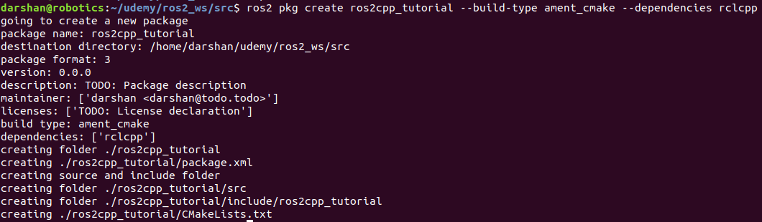

Architecture of c++ package

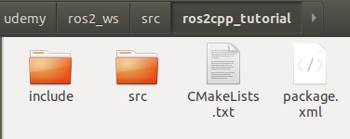

Keep all cpp nodes in src folder

Package.xml file

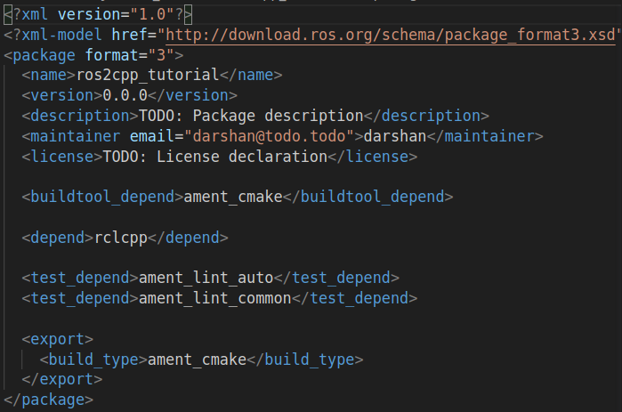

**Note:** Since compiling cpp scripts, build_type should be **“ament_cmake”.**

<build_type>ament_cmake</build_type>

<depend>rclcpp</depend>

Then it has a traditional CMakeList.txt file similar to ROS1 to support for the compiling cpp files.

Build package

$ cd ~ros2_ws

$ colcon build

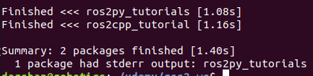

**Building particular package:**

$ colcon build --packages-select ros2cpp_tutorials

Note: ROS2 Installation key-error problem solving link

<https://stackoverflow.com/questions/74794022/curl-28-failed-to-connect-to-raw-githubusercontent-com-port-443-connection-t>

**Creating custom messages**

ROS 2 provides various inbuilt standard message formats to directly work with your application.

Sometimes you might need a specific message format relevant to your particular use case, that time ROS 2 will allow you to easily create your data types based message format.

Below steps describe the procedure in detail on creating your own custom message.

1. Create an interface package.
2. Create an msg folder inside the package.
3. Create a .msg file inside the msg folder and data types
4. Edit CMakeList & package.xml file
5. Compile the package

**Create an interface package**

mkdir -p custom_ws/src

cd custom_ws/src

ros2 pkg create --build-type ament_cmake custom_interfaces

cd ..

colcon build

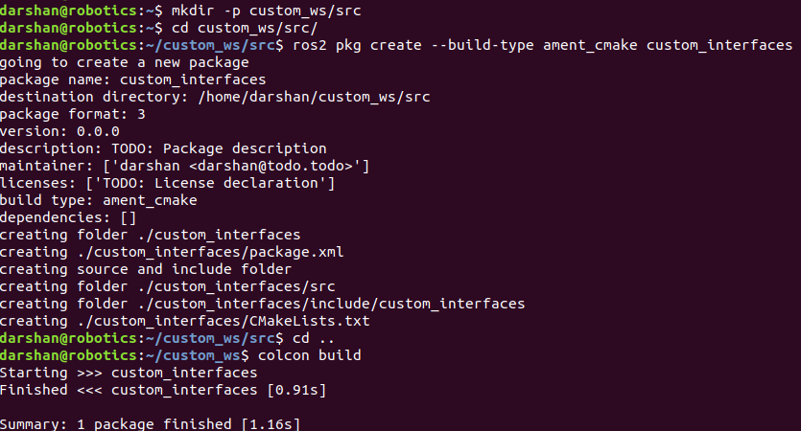

**Create msg directory inside package**

cd custom_ws/src/custom_interfaces

mkdir msg

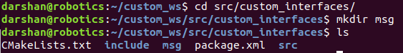

**Create a .msg file inside the msg folder.**

cd custom_ws/src/custom_interfaces/msg

code Person.msg



Note: **The file name should start with Capital letter. Ex: Person.msg or Test.msg.

Add data types inside the Person.msg file

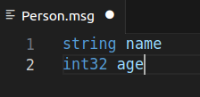

Note: **The message data types should start with lowercase letters. Ex: string name

**Edit CMakeList & package.xml file**

**Add the below information inside CmakeList file before ament_cmake():**

find_package(rosidl_default_generators REQUIRED)

find_package(geometry_msgs REQUIRED)

rosidl_generate_interfaces(${PROJECT_NAME}

"msg/Person.msg"

DEPENDENCIES geometry_msgs

)

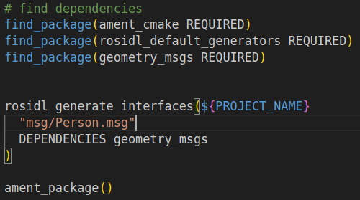

**Add the below information inside Package.xml file**

<depend>geometry_msgs</depend>

<buildtool_depend>rosidl_default_generators</buildtool_depend>

<exec_depend>rosidl_default_runtime</exec_depend>

<member_of_group>rosidl_interface_packages</member_of_group>

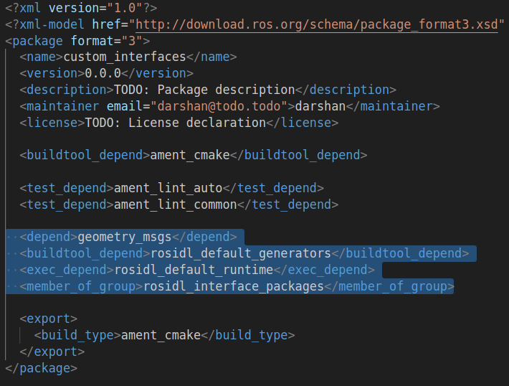

**Finally compile the package**

cd cust om_ws

colcon build --packages-select custom_interfaces

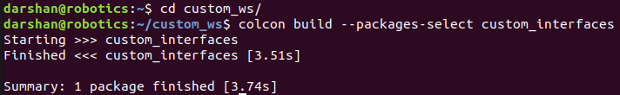

Using custom message formats in publisher and subscriber scripts. Have to create new package in order to use custom messages

Now you’re ready to use this custom message inside your publisher and subscriber scripts. So you can create a new package and inside that write a publisher and subscriber script using this custom message.

Creating new package

cd ~custom_ws/src

ros2 pkg create --build-type ament_cmake custom_pkg

cd ..

colcon build

Get into the src folder and write publisher and subscriber code using Person.msg message format.

cd ~custom_ws/src/custom_pkg/src

code publisher.cpp

#include <chrono>

#include <memory>

#include "rclcpp/rclcpp.hpp"

#include "custom_interfaces/msg/person.hpp" // CHANGE

using namespace std::chrono_literals;

class MinimalPublisher : public rclcpp::Node

{

public:

MinimalPublisher()

: Node("minimal_publisher"), count_(0)

{

publisher_ = this->create_publisher<custom_interfaces::msg::Person>("topic", 3); // CHANGE

timer_ = this->create_wall_timer(

500ms, std::bind(&MinimalPublisher::timer_callback, this));

}

private:

void timer_callback()

{

auto message = custom_interfaces::msg::Person();

message.name = "Darshan"; // CHANGE

message.age = 26; // CHANGE

RCLCPP_INFO(this->get_logger(), "I am sending : '%s' '%d'", message.name.c_str(), message.age);

publisher_->publish(message);

}

rclcpp::TimerBase::SharedPtr timer_;

rclcpp::Publisher<custom_interfaces::msg::Person>::SharedPtr publisher_; // CHANGE

size_t count_;

};

int main(int argc, char * argv[])

{

rclcpp::init(argc, argv);

rclcpp::spin(std::make_shared<MinimalPublisher>());

rclcpp::shutdown();

return 0;

}

code subscriber.cpp

#include <memory>

#include "rclcpp/rclcpp.hpp"

#include "custom_interfaces/msg/person.hpp"

using std::placeholders::_1;

class MinimalSubscriber : public rclcpp::Node

{

public:

MinimalSubscriber()

: Node("minimal_subscriber")

{

subscription_ = this->create_subscription<custom_interfaces::msg::Person>(

"topic", 10, std::bind(&MinimalSubscriber::topic_callback, this, _1));

}

private:

void topic_callback(const custom_interfaces::msg::Person::SharedPtr msg) const

{

RCLCPP_INFO(this->get_logger(), "I heard: '%s' '%d'", msg->name.c_str(), msg->age);

}

rclcpp::Subscription<custom_interfaces::msg::Person>::SharedPtr subscription_;

};

int main(int argc, char * argv[])

{

rclcpp::init(argc, argv);

rclcpp::spin(std::make_shared<MinimalSubscriber>());

rclcpp::shutdown();

return 0;

}

Edit CmakeLists.txt

Add executables and target dependencies

find_package(rclcpp REQUIRED)

add_executable(talker src/publisher.cpp)

ament_target_dependencies(talker rclcpp custom_interfaces) # CHANGE

add_executable(listener src/subscriber.cpp)

ament_target_dependencies(listener rclcpp custom_interfaces) # CHANGE

install(TARGETS

talker

listener

DESTINATION lib/${PROJECT_NAME})

Edit Package.xml

Add “custom_interfaces” depend block

<depend>custom_interfaces</depend>

Now compile the package

cd ~custom_ws

colcon build --packages-select custom_pkg

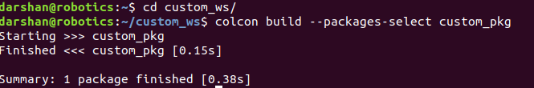

Custom service

Below steps describe the procedure in detail on creating your own custom message.

Create an srv folder inside the package.

Create a .srv file inside the msg folder and data types

Edit CMakeList & package.xml file

Compile the package

Create an srv folder inside the package.

cd custom_ws/src/custom_interfaces

mkdir srv



Create a .srv file inside the msg folder and data types

cd custom_ws/src/custom_interfaces/srv

code Value.srv

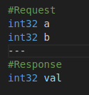

Edit CMakeLists.txt

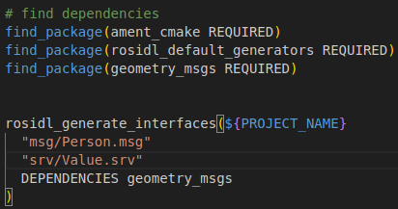

Package.xml  


Compile package

cd custom_ws

colcon build --packages-select custom_interfaces

Note: While compiling package sometime you’ll get below quoted error

“ rosidl_adapter.parser.InvalidServiceSpecification: Could not find separator

'---' between request and response “



To avoid this error, completely remove separation line ie, - - - inside .srv file rewrite “---”

Writing service server and service client script using this custom Value.srv file.

For that get into custom_pkg folder and write server & client script inside the src folder

service_server.cpp

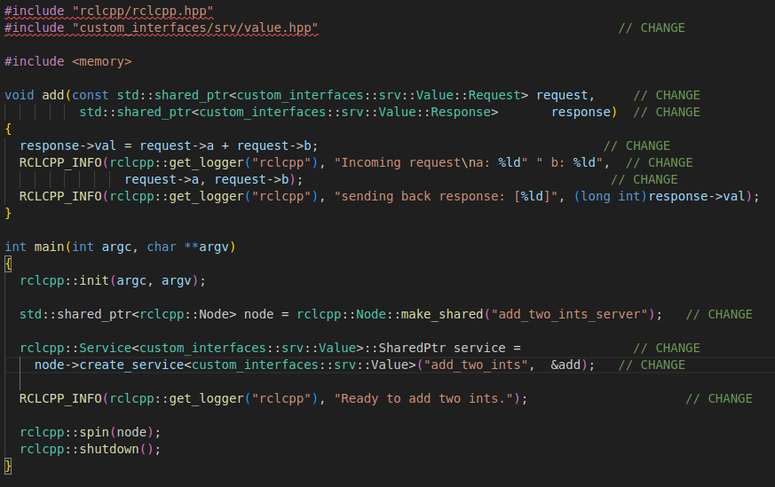

service_client.cpp

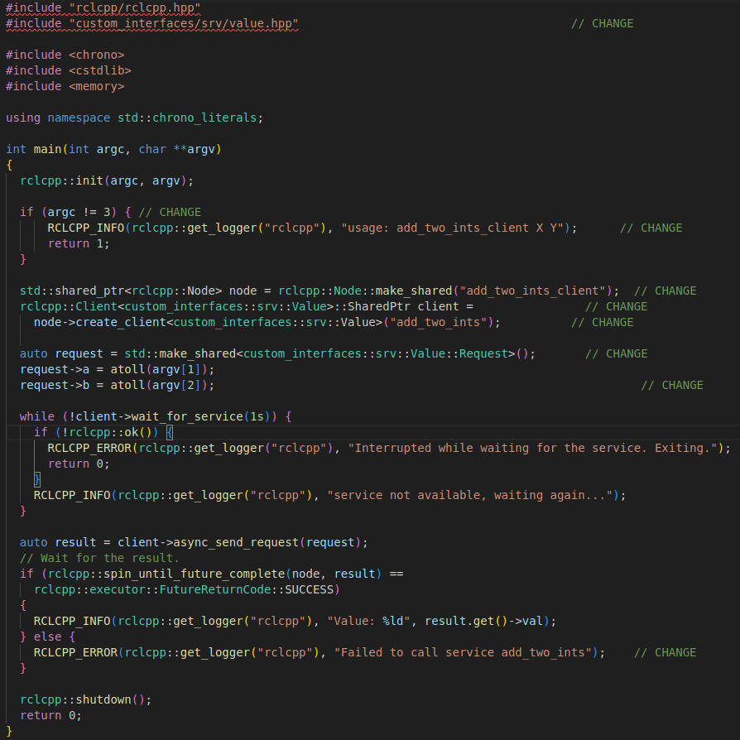

Edit CmakeLists.txt

#Custom service

add_executable(server src/service_server.cpp)

ament_target_dependencies(server

rclcpp custom_interfaces) # CHANGE

add_executable(client src/service_client.cpp)

ament_target_dependencies(client

rclcpp custom_interfaces) # CHANGE

install(TARGETS

server

client

DESTINATION lib/${PROJECT_NAME})

Editit Package.xml

<depend>custom_interfaces</depend>

Commands

**## Custom service**

Terminal 1:

ros2 run custom_pkg server

Terminal 2:

ros2 run custom_pkg client 10 9

**ROS TOOLS:**

1. Remapping the ROS 2 node while executing on command line

**$ ros2 run <package_name> <node_name> --ros-args --remap __node:=<remapping_name>**

**$ ros2 run training talker --ros-args --remap __node:=abc**

**(or)**

**$ ros2 run training talker --ros-args -r __node:=abc**

Note: By using this concept you can run the same node content with multiple times by changing node name.

EX:

**$ ros2 run training talker --ros-args --remap __node:=node1**

**$ ros2 run training talker --ros-args --remap __node:=node2**

**$ ros2 run training talker --ros-args --remap __node:=node3**

1. Building python packages : In ROS2 whenever you have made some changes in ros2.py code you need to compile the code again using colcon build options similar to ros1& ros2 cpp node. In order to avoid this you can use --symlink-install option at the time of building your ros2 python package; it will avoid building python script again and again after making changes in code.

**$ colcon build --packages-select action_tutorials_py --symlink-install**

4. ROS 2 topic debug and remapping

Allow ros2 publisher to publish at specific hz[ex: 10 hz]

$ ros2 topic pub -r 10 /talker <message_type> <message_data>

Find Bandwidth of topic

$ ros2 topic bw /talker

Remapping topic at runtime

**$ ros2 run <package_name> <node_name> --ros-args --remap <original_topic>:=<remapping_topic_name>**

**$ ros2 run training talker --ros-args --remap /topic:=/abc**

**(or)**

**$ ros2 run training talker --ros-args -r /topic:=/abc**